Machine Learning Analysis of English Premier League Matches
Allen, Zachary
Allen.642@wright.edu

Abstract- This report explores historical trends in the English Premier League (EPL) by applying a multi-faceted machine learning approach to a comprehensive dataset of match results. Using statistical analysis, we performed dimensionality reduction via Principal Component Analysis (PCA) to identify influential match features and employ K-means clustering to categorize match performance profiles. Furthermore, the study incorporates predictive analysis by implementing logistic regression and neural network models to forecast match outcomes. By comparing unsupervised clustering with supervised classification, this research demonstrates how latent data structures and non-linear patterns can be leveraged to understand and predict the competitive dynamics of Association Football.
GitHub Link: https://github.com/zmallen794-source/Premier-League-Predictive-Analysis
- Introduction
The English Premier League is one of the most unpredictable sports environments in the world. This study addresses the problem of identifying significant performance trends and predicting future outcomes with a dataset from 1993 to 2022. While traditional statistics focus on simple win/loss ratios, this research seeks to uncover the latent structures of match dynamics and build robust predictive frameworks
We contribute a systemic approach to match analysis by:
- Identifying the statistical features that define Premier League match variance through PCA
- Splitting matches into the following profiles: “Home Team Dominance”, “Away Team Dominance” and “Competitive”
- Developing predictive models using logistic regression and neural networks to classify match results
- Methodology
- Unsupervised Learning
Using PCA, we transform the 16-feature dataset into a 3-dimensional space to capture maximum variance. A K-Means algorithm (with n_init=10 and random_state=42) is then applied to group matches into k=3 clusters based on these components
- Supervised Learning
- Logistic Regression: A probabilistic model to determine linear relationships between match statistics and result probabilities
- Neural Networks: Utilized to capture complex, non-linear interactions between features to improve classification accuracy for match outcomes
- Experimental Setup
- Datasets
The study utilizes the results.csv dataset, containing several thousand Premier League games. Features include full-time and half-time goals (FTHG, FTAG, HTHG, HTAG) offensive volume (Shots, Shots on Target, Corners), and disciplinary metrics (Fouls, Yellow/Red Cards)
- Implementation Setup
All features were standardized using StandardScaler prior to dimensionality reduction to ensure that high-magnitude features did not disproportionately bias the PCA over low-magnitude features.

- Results
- Unsupervised Learning
When reviewing the PCA loading, one can see what is affecting the outcome of games the most.
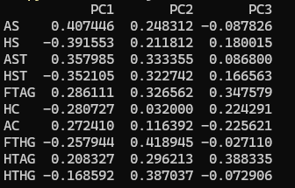
Figure 1. The loadings of each PCA for the ten most influential features in PC1

For PC1, the features that affect the most are Away Shots, Home Shots, and Home Shots on Target. For PC2, the top 3 features are Full-Time Home Goals, Half-Time Home Goals, and Away Shots on Target. For PC3, Half-Time Away Goals, Full-Time Away Goals are their primary features. Just looking at the top 3 in each of the PCs, the data seems to be relatively even in terms of what differentiate between match types (Home win, Away win, or Tie). However, since PC1 has a little bit more weight, it would stand to reason that the Away Team’s performance affects the results of the match slightly more than the home team.

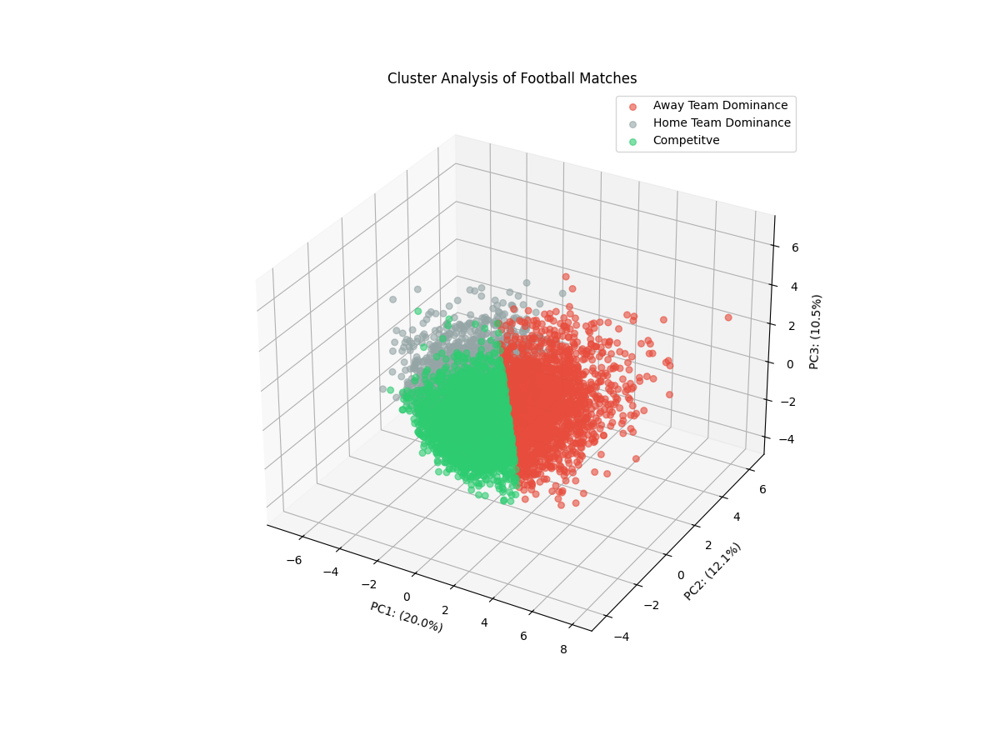
Figure 2. PCA-transformed match data
Figure 2 shows how each match type was clustered. While the location for each cluster can be a bit random, each grouping in this model was able to accurately separate between the three match types.
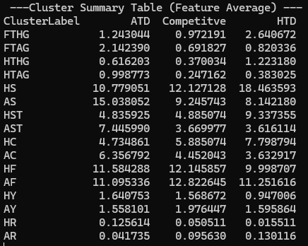
Figure 3. The average values for each feature for each cluster.

In the “Away Team Dominance” cluster, all the away team performance parameters are better than the home team performance parameters; the reverse is true for the “Home Team Dominance” cluster. This holds true all the way down to the home vs Away Red Cards. The Competitive, as expected, has the closest Full-Time Goal differential out of the three clusters. Both values are also below 1, indicating that a lot of these might end with a 0-0 or 1-0 result.
- Predictive Performance

- Discussion
The results confirm that scoring metrics and shot accuracy are more significant indicators of match trends than disciplinary actions. The higher loading value in PCA for Away Team Performance indicates that the away team dictates the result of the match more than the home team does. It also appears to be Competitive when there is the lowest amount of scoring occurring.
- Conclusion
This report demonstrates that a hybrid approach combining unsupervised clustering with supervised predictive modeling provides a comprehensive view of Premier League dynamics. While PCA and K-means identify the structural profiles of past matches, logistic regression and neural networks offer a framework for forecasting future competitive outcomes.

